cnc_wrzofsr

声明
/* write work zero offset value(area specified) */
[DllImport("FWLIB32.dll", EntryPoint = "cnc_wrzofsr")]
public static extern short cnc_wrzofsr(ushort FlibHndl, short a, [In, MarshalAs(UnmanagedType.LPStruct)] IODBZOR b);

描述
写工件坐标偏移。

参数
（1）FlibHndl 库句柄；[ in ]
（2）length [ in ]
（3）zofsr [ in ]
/* cnc_rdzofsr:read work zero offset value(area specified) */
/* cnc_wrzofsr:write work zero offset value(area specified) */
[StructLayout(LayoutKind.Sequential, Pack = 4)]
public class IODBZOR
{
public short datano_s; /* start offset number */
public short type; /* axis number */
public short datano_e; /* end offset number */
[MarshalAs(UnmanagedType.ByValArray, SizeConst = 7 * MAX_AXIS)]
public int[] data = new int[7 * MAX_AXIS]; /* offset value */
} /* In case that the number of axes is MAX_AXIS, the number of data is 7 */

函数返回值
函数运行正常返回EW_OK。
Return code | Meaning/Error handling
EW_LENGTH  (2) | Data block length error  Size of IODBZOR structure(length) is wrong.
EW_NUMBER  (3) | Data number error  Offset number(datano_s, datano_e) is wrong.
EW_ATTRIB  (4) | Data attribute error  Axis number(type) is wrong.
EW_DATA  (5) | Data error (Series 15, 30i)  Offset data(data) is out of range.
EW_NOOPT  (6) | No option (Series 16/18/21, 16i/18i/21i, 0i, 30i)  This function needs the work zero offset option.

代码
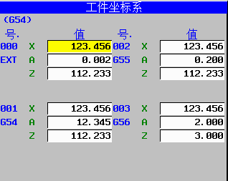
class Program
{
static void Main(string[] args)
{
ushort Flibhndl = 0;

short ret; // 返回值

// 获取库句柄 ( Ethernet )
ret = Focas1.cnc_allclibhndl3("192.168.0.224", 8193, 10, out Flibhndl);
if (ret != Focas1.EW_OK)
{
Console.WriteLine("发生异常，请检查！");
return;
}

#region cnc_wrzofsr

short length = 520;
Focas1.IODBZOR zofsr = new Focas1.IODBZOR();
zofsr.datano_s = 0;
zofsr.datano_e = 3;
zofsr.data[0] = 123456;
zofsr.data[1] = 123456;
zofsr.data[2] = 123456;
zofsr.data[3] = 123456;
zofsr.type = 1;
ret = Focas1.cnc_wrzofsr(Flibhndl, length, zofsr);
#endregion
}
}

